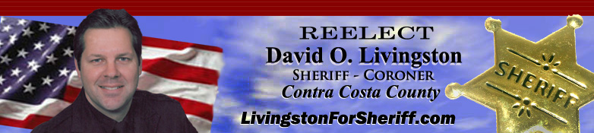
Donation Form
YES! I would like to support David Livingston’s Re-Election for Sheriff-Coroner.

Please make a donation in the amount of $ ______________
(If by check, please make check payable to: Re-Elect David Livingston Sheriff)
Credit Card Info: □Visa □M.C. □Amex
Credit Card Number: ________________________________
Expiration Date: _____________ Security Code __________
Name as it appears on card: __________________________
(Please Note: Supporters who make the maximum individual donation allowed, ($1675.00) in this re-election cycle are automatically enrolled in the Sheriff’s Cavalry. Although any donation amount is appreciated, the maximum donation amount of $1675.00 per person can be made only once every four-year election cycle. Note: Effective March 2, 2022, that maximum amount is raised to $2500.00 per election cycle.
Required Information:
Name: ___________________________________________
Address: _________________________________________
City: ________________________ State:____ Zip:________
Phone: _______________ Email: ______________________
Occupation: _______________________________________
Employer/Affiliation: _________________________________
Signature: _________________________________________

Please Mail To: Re-Elect David Sheriff Livingston
P.O. Box 487
Danville, CA 94526

Questions? Visit www.LivingstonForSheriff.com or call (925) 265-4422 Thank you.

